Steps to create view for Marketing VOB:

The new VOB for MARKETING has been created with a new branching and merging strategy, thus when you have to create a new view , “Join Project” as done before will not work.
In the new strategy views have to be created on the child streams under each projects Integration stream
Below is the existing list of projects and their child streams, before starting off with the view creation make sure on which stream you have to create the view

Note: You need to have access to the project, if you do not have access please raise a ticket at http://172.21.154.6/ITWayFeedback/feedback.html and then follow the steps mentioned here.

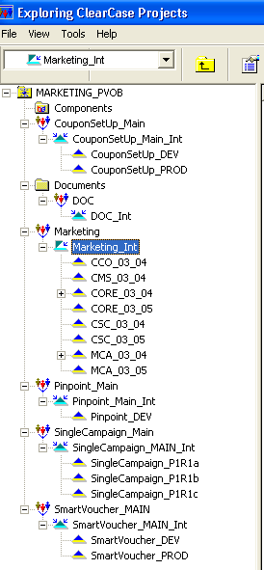

The documents from the Base CC VOBs - Clubcard_Mailing, Group_MKT, Group_TSM and SmartVoucher (created as SmartVoucher_Support) are imported under the DOC project (as listed in the above screen shot), below screen shot has the list of folders under DOCS folder
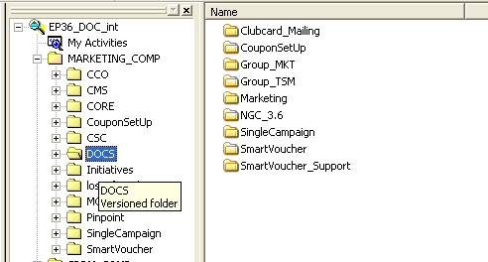

The below procedure has to be followed for view creation, after identifying the project and the stream within.

- Before creating a view, you should have a shared folder in your system D: as below
- Create a folder named “ccviews” under D:\ ; right-click and select “Sharing and Security”
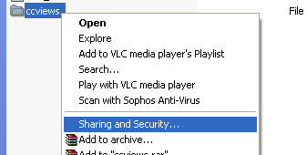

- Share and provide full permissions as below

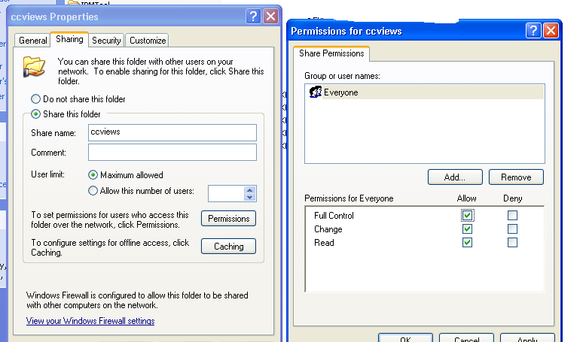

- Click on the “Security” tab ➔ Select your name ➔ Select full control ( as below)
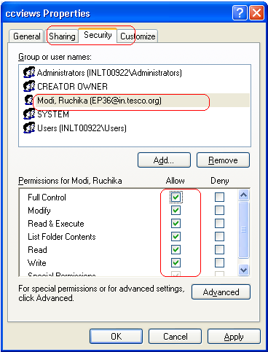

Note: You need to have local admin rights on your system to share the folder, if you do not have the rights please Contact http://ithelp/caisd/

- Open Clearcase Project explorer
Start -> Programs -> Rational Software -> Rational Clearcase -> Project Explorer
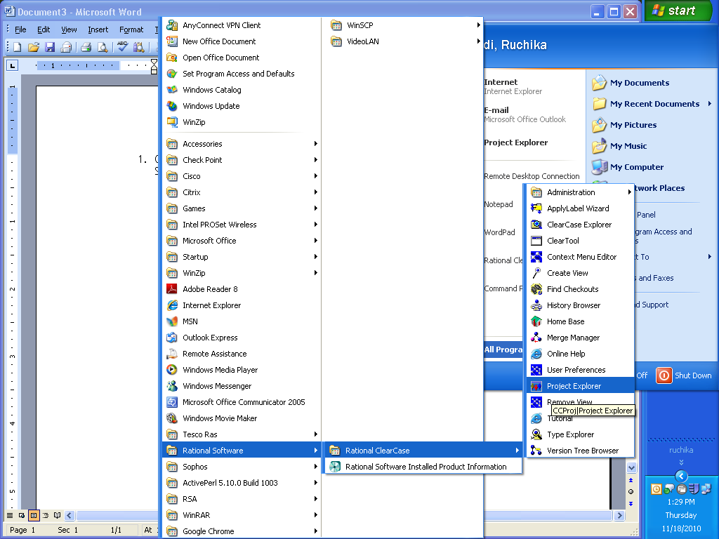

- Make sure “show all project VOBs” option is selected –
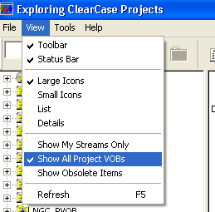

- Browse to your PVOB -> project -> stream on which the view has to be created
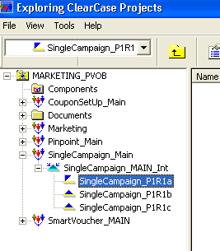

- Right click on the stream you want to create a view on and select “create view”
You will see the below window – which will create 2 views (one on the DEV stream and the other on Int stream)

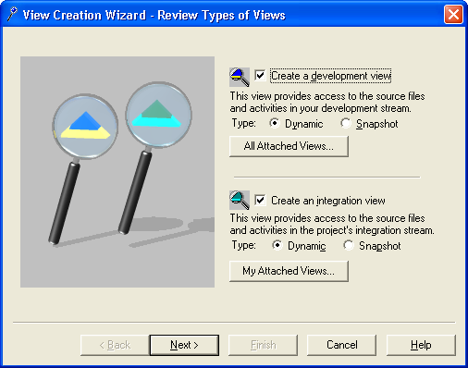

Click Next.

- In the next window
  - rename the view as <tpxId>_streamname (as below)
  - Select drive as “none “a view for the first time on the system, then you have to click on “Advanced Options” and select the shared “views” folder created on D: drive.
  - If you are creating a view for the first time, click on “Advanced options”
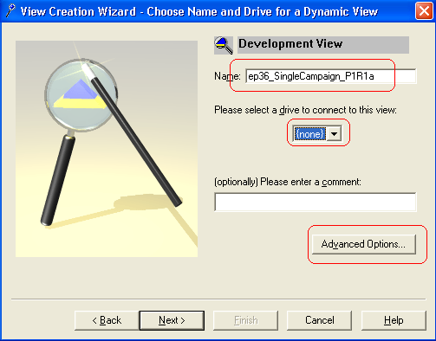

- Click on Browse and select the shared folder we had created in the 1st step. ➔ OK
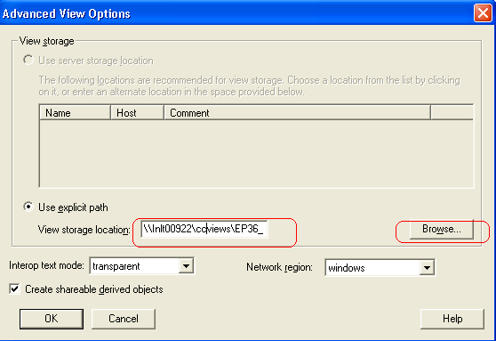

- Now it will go back to the previous window ➔ Next
In the next window also follow the same steps as above and click on finish
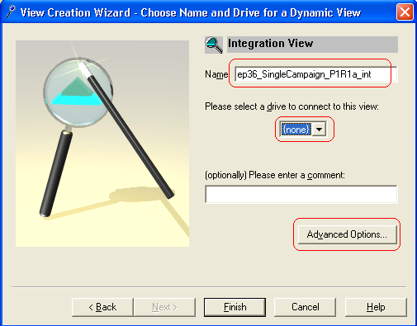

- Verify the view names and Say OK on the next window
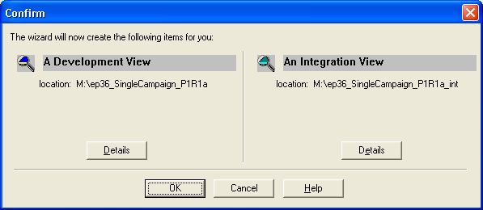

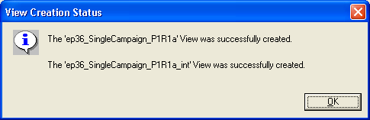

- Then open The Clearcase explorer and add both the view shortcuts
- In the left-hand pane ➔ Add View Shortcut
- In the next window ➔ select “View type” as “Dynamic”
- In the View tag, locate the view you have created ➔ OK.
